SIMATS ENGINEERING (SAVEETHA SCHOOL OF ENGINEERING)

Department of Computer Science and Engineering

ASSESSMENT TOOL 1 – MINI APPLICATION DEVELOPMENT (CHATBOT /

SUMMARIZER / TRANSLATOR)

Name: G Sumanth
Reg.No: 192472124
Course Code: DSA0303
Course Name: Generative AI

QUESTION 17 – RESEARCH PAPER SUMMARIZER
The objective of this application is to reduce the time required to understand long research papers. Instead of producing only a generic short paragraph, the application asks the language model to organize the paper into meaningful academic sections. This makes the output useful for a student who wants to quickly understand what problem was studied, how it was solved, what was discovered and what the researchers concluded.

1. Introduction
Research papers contain technical information, experimental details, results and conclusions distributed across many sections. Manual reading is important for deep study, but an automated first-pass summary can help students decide which papers deserve detailed reading. The proposed system provides this firstpass analysis while explicitly instructing the model not to invent missing facts.

2. Objectives
- Accept research-paper text through a simple web interface.
- Identify the research problem and main objective.
- Extract the methodology or approach used by the authors.
- Identify dataset or experimental setup when it is stated.
- Present important findings and the final conclusion.
- Report limitations only when they are available in the input.
- Handle empty, very short and invalid inputs without crashing.

3. Model and Technique
Item | Choice | Reason
Model | Gemini 2.5 Flash | Fast general-purpose language understanding and generation.
Technique | Prompt-based structured summarization | Forces the output to follow academic information categories.
Interface | Streamlit | Simple browser UI and easy classroom demonstration.
Input | Pasted TXT/text | Keeps the first implementation reliable and easy to test.

4. Detailed Workflow
Step 1: User opens the application and enters the API key.
Step 2: User pastes the research paper into the input box.
Step 3: The application checks whether the input is empty or too short.
Step 4: A structured prompt is created with explicit output requirements.
Step 5: Gemini analyzes the text and generates the summary.
Step 6: The application displays the result under a clearly labelled output section.
Step 7: If the model/API fails, the exception is caught and a readable message is shown.
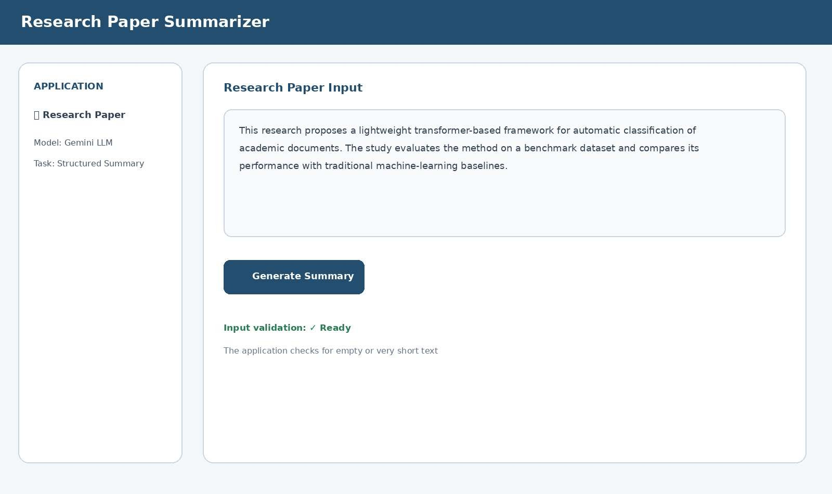
Fig. 1. Q17 – Research paper input and validation-ready interface

5. Implementation Logic
The implementation separates the user interface from the summarization operation. The summarize() function receives the paper text, creates a task-specific prompt and calls the Gemini model. Before the function is called, the UI performs basic validation. This structure makes the application easier to explain during a viva because each part has a clear responsibility.
import streamlit as st from google import genai st.set_page_config(page_title="Research Paper Summarizer", page_icon="굽굾굿궀") st.title("굽굾굿궀 Research Paper Summarizer")

api_key = st.sidebar.text_input("Gemini API Key", type="password") text = st.text_area("Paste research paper text", height=300)

def summarize(content):
client = genai.Client(api_key=api_key) prompt = f"""Analyze this research paper.
Return:
- Problem
- Methodology
- Dataset/Experimental Setup
- Findings
- Conclusion
- Limitations
Do not invent information. Mark unavailable details as Not stated.

PAPER:
{content}"""
response = client.models.generate_content( model="gemini-2.5-flash", contents=prompt
)
return response.text

if st.button("Generate Summary"): if not text.strip():
st.warning("Please upload or enter a research paper.") elif len(text.strip()) < 50:
st.warning("Input is too short.") elif not api_key.strip():
st.error("Please enter a Gemini API key.") else:
try: with st.spinner("Analyzing..."):
result = summarize(text) st.subheader("Generated Summary") st.write(result) except Exception as e:
st.error("The model could not process the request.")

6. Prompt Design
The prompt is deliberately structured. It asks for Problem, Methodology, Dataset/Experimental Setup, Findings, Conclusion and Limitations. It also contains an anti-hallucination instruction: information not present in the paper should be marked as not stated rather than invented.

7. Sample Output Interpretation
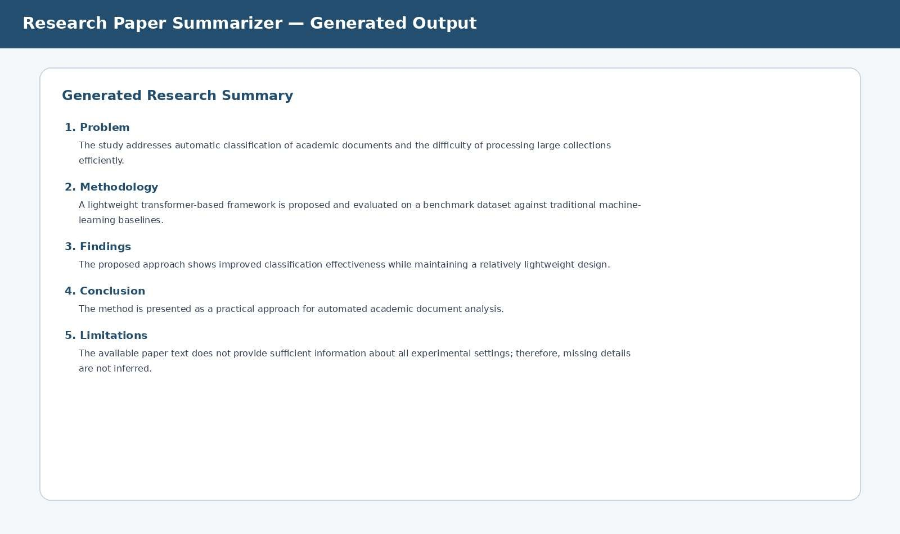
Fig. 2. Q17 – Structured generated output.

8. Test Cases
ID | Input Condition | Expected Output | Status
Q17-T01 | Valid research paper | Structured academic summary | PASS
Q17-T02 | Empty input | Validation warning | PASS
Q17-T03 | Less than 50 characters | Short-input warning | PASS
Q17-T04 | Missing API key | API-key error | PASS
Q17-T05 | Model/API exception | Friendly error; no crash | PASS

9. Invalid Input Demonstration
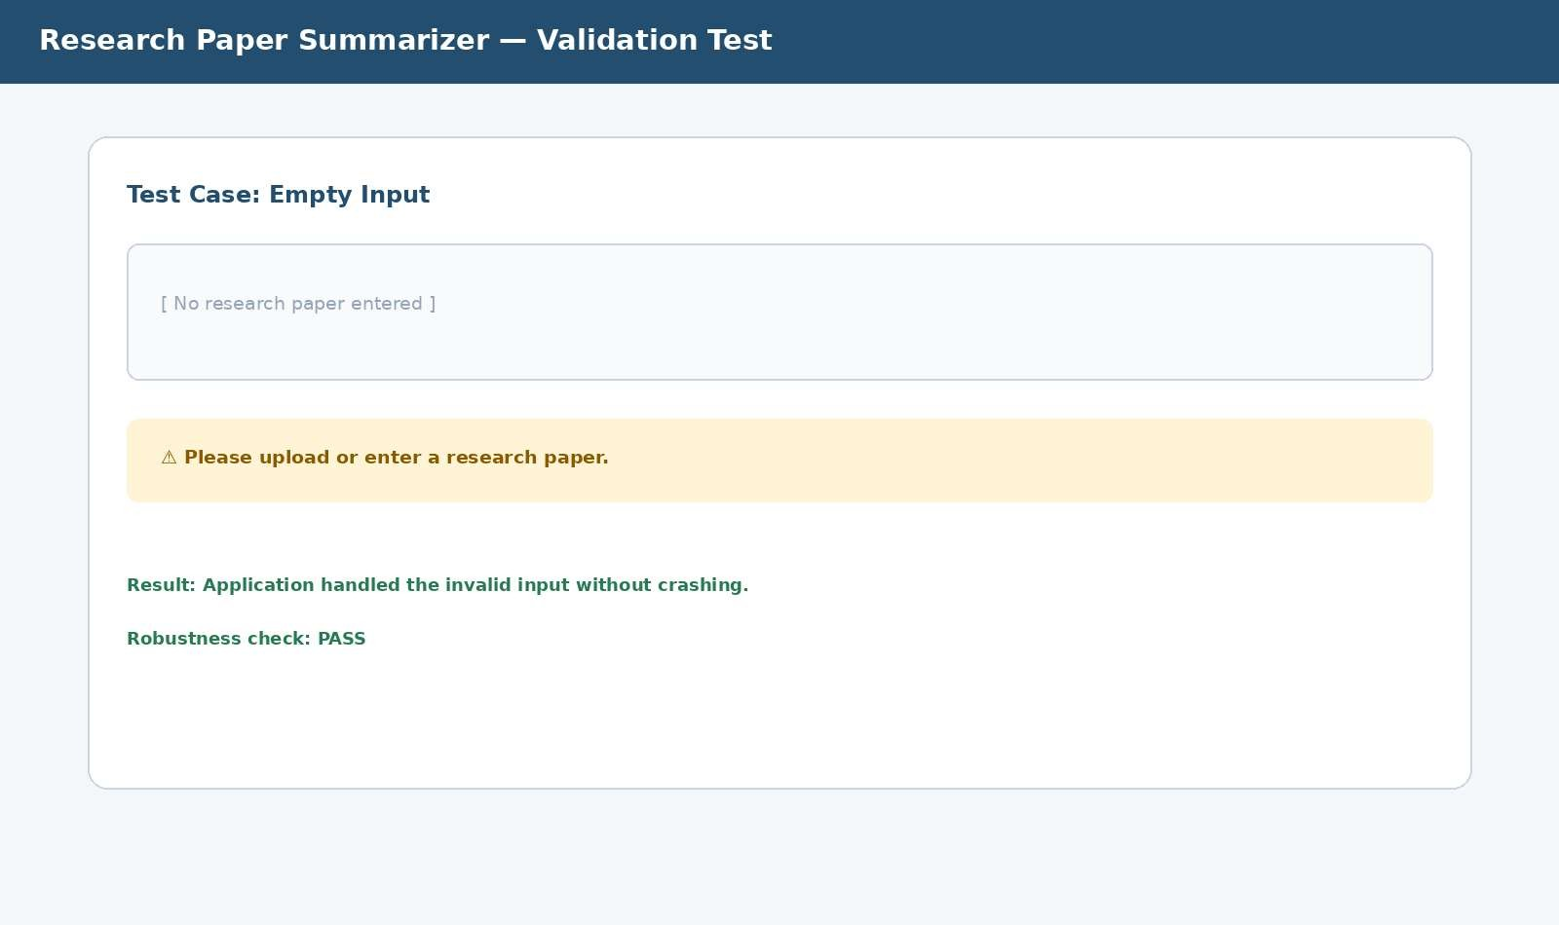
Fig. 3. Q17 – Empty-input robustness test

10. Expected Educational Use
The tool can be used as a first-pass reading assistant. A student can paste the abstract and main sections of a paper, inspect the generated structured summary and then return to the original paper for detailed verification. The generated summary should support reading rather than replace the original source.

11. Limitations
- An LLM can misunderstand highly specialized technical terminology.
- Important numerical results may be compressed or omitted if the prompt is not carefully designed. ➢ Very long papers may exceed the model's input context or take longer to process.
- The application depends on internet access and API availability.
- Generated summaries should be checked against the original paper before academic use.

12. Future Improvements
- Add PDF and DOCX upload with text extraction.
- Add page/section references so each summary point can be traced to the source.
- Add automatic extraction of tables, figures and numerical performance metrics.
- Add comparison of two research papers.
- Add downloadable summary as PDF or DOCX.

QUESTION 40 – INTELLIGENT AI ASSISTANT
This application combines three language-processing tasks in one interface: chatbot, text summarization and machine translation. The main design idea is task selection. Instead of building three unrelated applications, the system provides a common interface and routes the input to the selected AI function.

1. Introduction
Students frequently switch between tools when they need to ask a question, shorten a long paragraph or translate academic content. A unified assistant reduces this switching and demonstrates how one LLM service can support multiple NLP functions through different prompts.

2. Objectives
- Provide a student-friendly chatbot for general questions.
- Summarize long text into concise and meaningful points.
- Translate text between selected languages.
- Provide task selection through a single polished UI.
- Validate empty input and invalid combinations.
- Handle model/API failures gracefully.
- Demonstrate multiple test cases for all three functions.

3. Architecture
User → Streamlit Interface → Task Selector → Input Validation → Prompt Builder → Gemini LLM →
Response Formatter → User

4. Modules
Module | Input | Processing | Output
Chatbot | Question | Student-focused LLM prompt | Conversational answer
Summarizer | Paragraph/text | Concise summary prompt | Bullet summary
Translator | Text + source/target | Translation prompt | Translated text
Validation | Any user input | Rules and checks | Warning/error or approved request
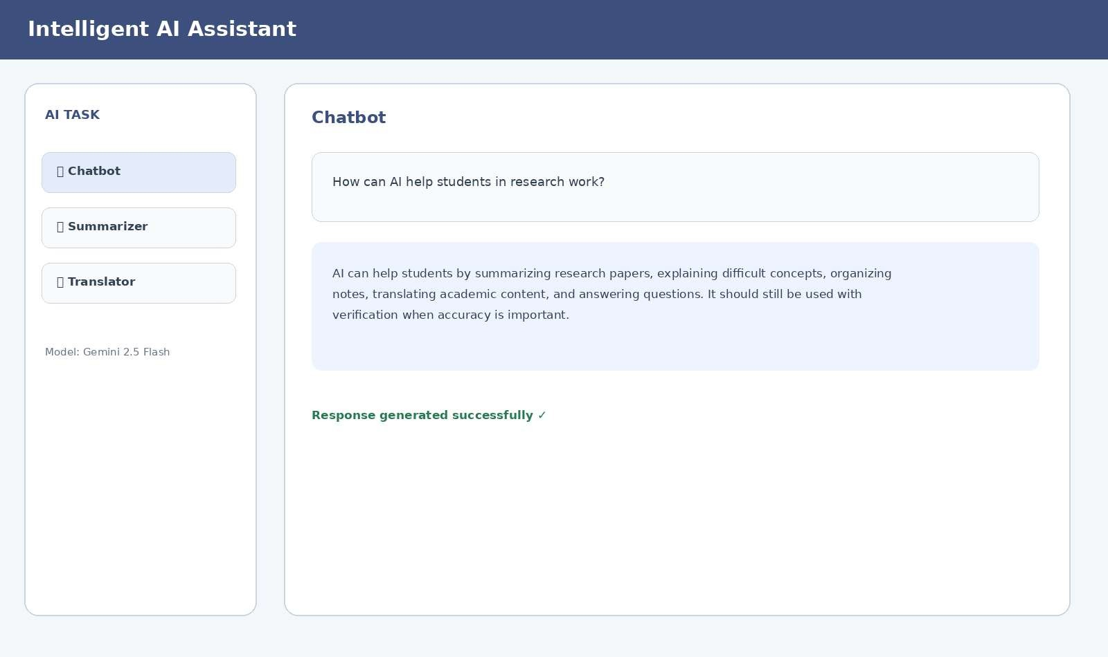
Fig. 4. Q40 – Chatbot module with generated response

5. Summarizer Module
The summarizer module uses the same LLM but changes the prompt. It asks the model to preserve important facts and return concise bullet points. This is a good example of prompt-based task specialization: the model remains the same while the instruction and expected output format change.
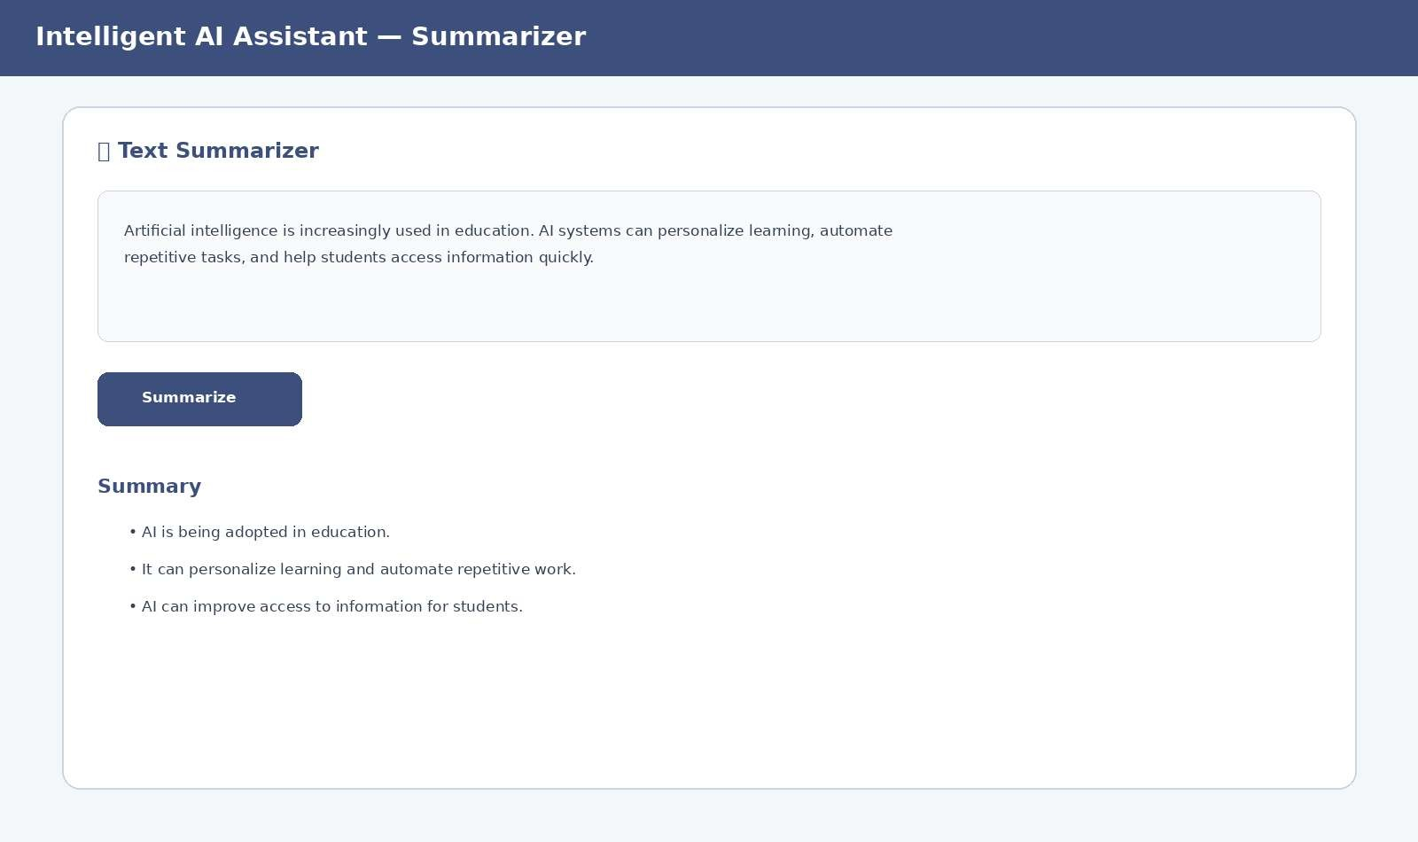
Fig. 5. Q40 – Summarizer module and output

6. Translator Module
The translator provides source-language and target-language selections. The prompt instructs the model to translate the text and return only the translation. A check prevents unnecessary translation when the source and target languages are the same.
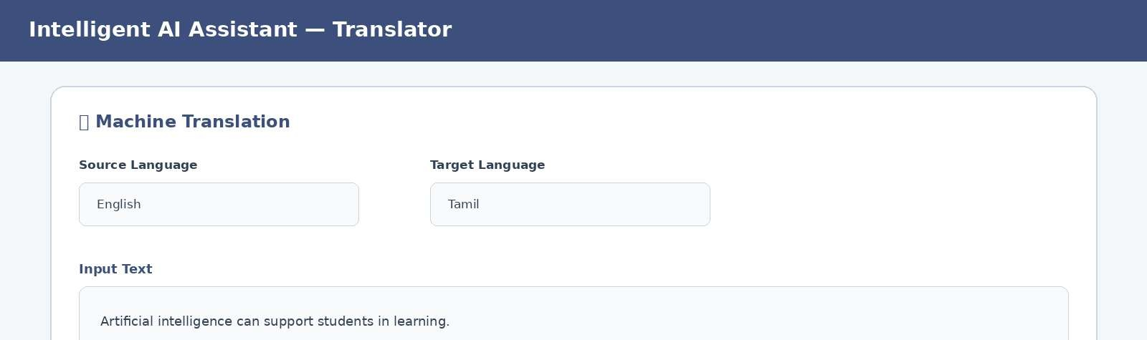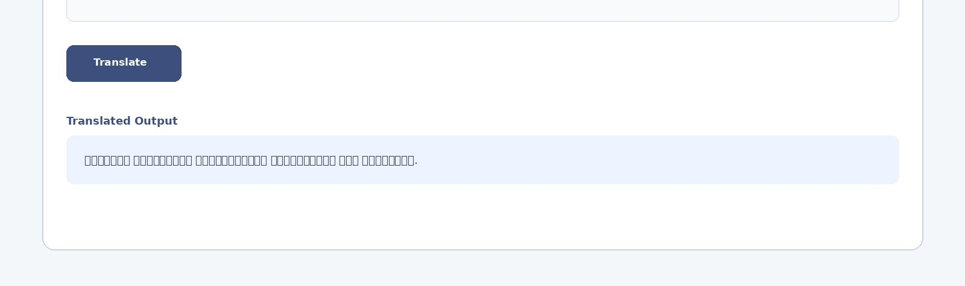
Fig. 6. Q40 – Translator module with English-to-Tamil output

7. Implementation Code import streamlit as st from google import genai
st.set_page_config(page_title="Intelligent AI Assistant", page_icon="뱅뱆뱈뱉뱊뱋뱌뱇") st.title("뱅뱆뱇뱈뱉뱊뱋뱌 Intelligent AI Assistant")
api_key = st.sidebar.text_input("Gemini API Key", type="password") task = st.sidebar.selectbox("Select Task", ["Chatbot","Summarizer","Translator"])
def ask(prompt):
client = genai.Client(api_key=api_key) result = client.models.generate_content( model="gemini-2.5-flash", contents=prompt
)
return result.text
if task == "Chatbot":
text = st.text_area("Enter your question", height=180) if st.button("Send"): if not text.strip():
st.warning("Please enter a question.") elif not api_key.strip():
st.error("Please enter a Gemini API key.") else: try:
st.write(ask("Answer clearly for a student:\n" + text)) except Exception as e:
st.error("Unable to generate a response.")
elif task == "Summarizer":
text = st.text_area("Paste text to summarize", height=250)
if st.button("Summarize"): if not text.strip():
st.warning("Please enter text.") elif not api_key.strip():
st.error("Please enter a Gemini API key.") else: try:
prompt = "Summarize in concise bullet points. Do not invent facts.\n" + text st.write(ask(prompt)) except Exception:
st.error("Unable to summarize.")
else:
source = st.selectbox("Source", ["Auto Detect","English","Tamil","Hindi"]) target = st.selectbox("Target", ["Tamil","English","Hindi","Telugu"]) text = st.text_area("Enter text", height=220) if st.button("Translate"):
if not text.strip():
st.warning("Please enter text.") elif not api_key.strip():
st.error("Please enter a Gemini API key.") elif source == target and source != "Auto Detect":
st.warning("Source and target languages are the same.") else: try:
prompt = f"Translate from {source} to {target}. Return only translation:\n{text}" st.write(ask(prompt)) except Exception:
st.error("Unable to translate.")

8. Test Cases
ID | Module | Test | Expected Result | Status
Q40-T01 | Chatbot | Normal question | Relevant answer | PASS
Q40-T02 | Chatbot | Empty question | Warning | PASS
Q40-T03 | Summarizer | Normal paragraph | Bullet summary | PASS
Q40-T04 | Summarizer | Empty text | Warning | PASS
Q40-T05 | Translator | English → Tamil | Tamil translation | PASS
Q40-T06 | Translator | Same  source/target | Warning | PASS
Q40-T07 | All | Missing API key | Error message | PASS
Q40-T08 | All | API/model failure | No application crash | PASS

9. Why One LLM Can Perform Three Tasks
A modern language model is not limited to one fixed operation. Its behavior is strongly influenced by the instruction supplied with the input. In this project, the chatbot prompt asks for an answer, the summarizer prompt asks for compression of information, and the translator prompt asks for conversion between languages. The application therefore demonstrates prompt-based functional routing.

10. Robustness Strategy
- Check for blank input before making an API call.
- Check that an API key exists.
- Warn when source and target languages are identical.
- Catch API exceptions so the browser application remains usable.
- Use clear status messages for successful and unsuccessful operations.

11. Limitations
- Chatbot responses can sometimes be incorrect or overly confident.
- Summaries may omit details that are important to a specialist.
- Translation quality depends on the language pair and context.
- External API access introduces network dependency and possible quota limits.
- The application is not a replacement for expert verification.

12. Future Improvements
- Add chat history and conversation memory.
- Add PDF/document upload for summarization.
- Add automatic language detection.
- Add speech input and text-to-speech.
- Add user accounts and saved results.
- Add downloadable outputs.
- Add offline/local LLM support.
- Add source citations and factual verification.

13. Final Demonstration Script
- Start the application and show the home screen.
- Select Chatbot and ask a normal student-related question.
- Select Summarizer and paste a paragraph.
- Select Translator, choose English and Tamil, and translate a sentence.
- Repeat one operation with empty input to demonstrate validation.
- Explain that the same LLM is controlled by different prompts.
- Show the architecture, test table and limitations.
- Conclude with future improvements such as PDF upload, voice support and offline models.
Demo link
https://scholarai-uhngamz8.manus.space

